ITA0435 – STATISTICS WITH R PROGRAMMING FOR VISUALIZATION
NAME : R.SABARISH
REG NO ; 192324092
UNIT IV EXPLORATORY DATA ANALYSIS IN R
1.ADVERTISEMENT SPENDING AND SALES RELATIONSHIP
# =====================================================
# ADVERTISEMENT SPENDING AND SALES RELATIONSHIP
# =====================================================

# Monthly Data for 3 Years (36 Observations)

Advertisement <- c(20,22,25,30,28,35,40,38,45,50,48,55,
23,26,27,32,30,36,42,39,46,52,49,58,
24,28,29,33,31,37,43,41,47,53,51,60)

Sales <- c(200,210,230,260,250,280,310,300,340,370,360,400,
215,240,245,270,265,290,320,310,350,380,370,420,
220,250,255,275,270,295,330,315,360,390,375,430)

data <- data.frame(Advertisement, Sales)

# -----------------------------------------------------
# 1. Univariate EDA
# -----------------------------------------------------

cat("Summary Statistics - Advertisement\n")
print(summary(data$Advertisement))
cat("Standard Deviation:", sd(data$Advertisement), "\n\n")

cat("Summary Statistics - Sales\n")
print(summary(data$Sales))
cat("Standard Deviation:", sd(data$Sales), "\n\n")

# Histograms
hist(data$Advertisement,
main="Advertisement Spending Distribution",
xlab="Advertisement Spending",
col="lightblue")

hist(data$Sales,
main="Sales Revenue Distribution",
xlab="Sales Revenue",
col="lightgreen")

# -----------------------------------------------------
# 2. Covariance
# -----------------------------------------------------

covariance_value <- cov(data$Advertisement, data$Sales)
cat("Covariance between Advertisement and Sales:\n")
print(covariance_value)

# -----------------------------------------------------
# 3. Correlation Coefficient
# -----------------------------------------------------

correlation_value <- cor(data$Advertisement, data$Sales)
cat("Correlation Coefficient:\n")
print(correlation_value)

if(correlation_value > 0.7){
cat("Interpretation: Strong Positive Relationship\n")
} else if(correlation_value > 0.3){
cat("Interpretation: Moderate Positive Relationship\n")
} else {
cat("Interpretation: Weak Relationship\n")
}

# -----------------------------------------------------
# 4. Scatter Plot
# -----------------------------------------------------

plot(data$Advertisement, data$Sales,
main="Scatter Plot: Advertisement vs Sales",
xlab="Advertisement Spending",
ylab="Sales Revenue",
pch=19,
col="blue")

abline(lm(Sales ~ Advertisement, data=data), col="red", lwd=2)

# -----------------------------------------------------
# 5. Covariance vs Correlation Explanation
# -----------------------------------------------------

cat("\nDifference Between Covariance and Correlation:\n")
cat("1. Covariance shows direction of relationship (positive/negative).\n")
cat("2. Covariance value depends on units of measurement.\n")
cat("3. Correlation shows both strength and direction.\n")
cat("4. Correlation is standardized between -1 and +1.\n")
cat("5. In this dataset, positive covariance and high positive correlation indicate that higher advertisement spending leads to higher sales.\n")

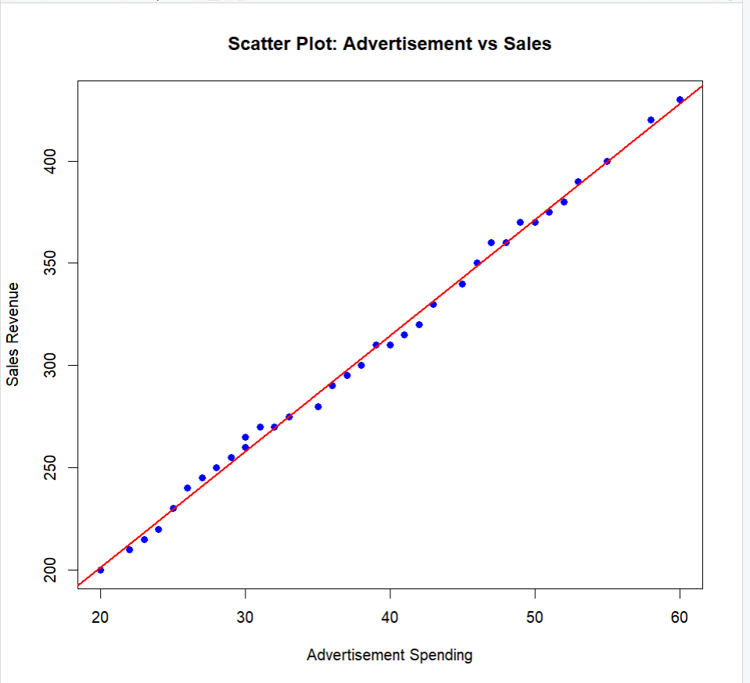
2. GENDER-BASED ENROLLMENT ANALYSIS
# =====================================================
# GENDER-BASED ENROLLMENT ANALYSIS
# =====================================================

# Sample Dataset

Gender <- c("Male","Female","Male","Female","Male","Female",
"Male","Female","Male","Female","Male","Female",
"Male","Male","Female","Female","Male","Female",
"Male","Female")

Course <- c("B.Tech","B.Tech","BBA","BBA","B.Sc","B.Sc",
"B.Tech","B.Sc","BBA","B.Tech","B.Sc","BBA",
"B.Tech","B.Sc","B.Tech","BBA","B.Tech","B.Sc",
"BBA","B.Tech")

data <- data.frame(Gender, Course)

# -----------------------------------------------------
# 1. Crosstab (Contingency Table)
# -----------------------------------------------------

crosstab <- table(data$Gender, data$Course)

cat("Crosstab (Gender vs Course):\n")
print(crosstab)

# -----------------------------------------------------
# 2. Interpretation of Contingency Table
# -----------------------------------------------------

cat("\nRow-wise Percentage Distribution:\n")
print(prop.table(crosstab, margin = 1) * 100)

cat("\nColumn-wise Percentage Distribution:\n")
print(prop.table(crosstab, margin = 2) * 100)

# -----------------------------------------------------
# 3. Univariate EDA (Total Enrollment per Course)
# -----------------------------------------------------

course_total <- table(data$Course)

cat("\nTotal Enrollment per Course:\n")
print(course_total)

cat("\nPercentage Distribution per Course:\n")
print(prop.table(course_total) * 100)

# -----------------------------------------------------
# 4. Bar Charts for Graphical Analysis
# -----------------------------------------------------

# Bar Chart for Total Enrollment
barplot(course_total,
main="Total Enrollment per Course",
xlab="Course",
ylab="Number of Students",
col="lightblue")

# Stacked Bar Chart for Gender-wise Distribution
barplot(crosstab,
beside=FALSE,
legend=TRUE,
main="Gender-wise Enrollment Distribution",
col=c("pink","skyblue"))

# Side-by-Side Bar Chart
barplot(crosstab,
beside=TRUE,
legend=TRUE,
main="Gender vs Course (Side-by-Side)",
col=c("pink","skyblue"))

# -----------------------------------------------------
# 5. Explanation (Printed Output)
# -----------------------------------------------------

cat("\nExplanation:\n")
cat("1. Crosstab shows enrollment distribution between gender and courses.\n")
cat("2. Univariate EDA shows overall popularity of each course.\n")
cat("3. Bar charts visually represent categorical comparisons.\n")
cat("4. Quantitative EDA gives exact counts and percentages.\n")
cat("5. Graphical EDA helps quickly identify patterns and trends.\n")
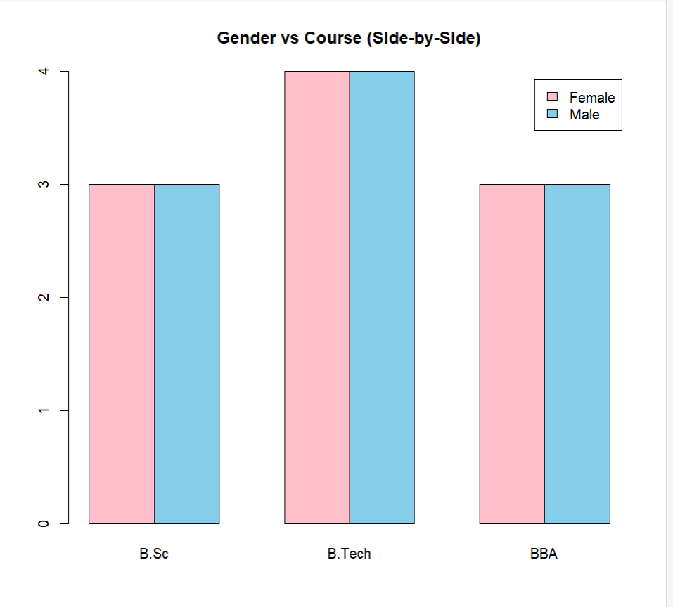

3. ANNUAL TEMPERATURE TREND STUDY
# =====================================================
# ANNUAL TEMPERATURE TREND STUDY
# =====================================================

# Generate Sample Daily Temperature Data for 365 Days
set.seed(123)

temperature <- rnorm(365, mean = 28, sd = 5)

# -----------------------------------------------------
# 1. Mean, Median, Mode
# -----------------------------------------------------

mean_temp <- mean(temperature)
median_temp <- median(temperature)

# Mode function (for numeric data - approximate)
mode_temp <- as.numeric(names(sort(table(round(temperature,1)),
decreasing = TRUE)[1]))

cat("Mean Temperature:", mean_temp, "\n")
cat("Median Temperature:", median_temp, "\n")
cat("Mode Temperature (Approx):", mode_temp, "\n\n")

# -----------------------------------------------------
# 2. Min, Max, Range, Variance, SD
# -----------------------------------------------------

min_temp <- min(temperature)
max_temp <- max(temperature)
range_temp <- max_temp - min_temp
variance_temp <- var(temperature)
sd_temp <- sd(temperature)

cat("Minimum Temperature:", min_temp, "\n")
cat("Maximum Temperature:", max_temp, "\n")
cat("Range:", range_temp, "\n")
cat("Variance:", variance_temp, "\n")
cat("Standard Deviation:", sd_temp, "\n\n")

# -----------------------------------------------------
# 3. Quartiles & Interquartile Range (IQR)
# -----------------------------------------------------

quartiles <- quantile(temperature)
iqr_temp <- IQR(temperature)

cat("Quartiles:\n")
print(quartiles)
cat("Interquartile Range (IQR):", iqr_temp, "\n\n")

# -----------------------------------------------------
# 4. Skewness and Kurtosis (Manual Calculation)
# -----------------------------------------------------

n <- length(temperature)
mean_val <- mean(temperature)
sd_val <- sd(temperature)

skewness <- sum((temperature - mean_val)^3) / ((n - 1) * sd_val^3)
kurtosis <- sum((temperature - mean_val)^4) / ((n - 1) * sd_val^4)

cat("Skewness:", skewness, "\n")
cat("Kurtosis:", kurtosis, "\n\n")

if(skewness > 0){
cat("Distribution is Positively Skewed\n")
} else if(skewness < 0){
cat("Distribution is Negatively Skewed\n")
} else {
cat("Distribution is Symmetric\n")
}

if(kurtosis > 3){
cat("Leptokurtic (Heavy Tails)\n")
} else if(kurtosis < 3){
cat("Platykurtic (Light Tails)\n")
} else {
cat("Mesokurtic (Normal Distribution)\n")
}

# -----------------------------------------------------
# 5. Histogram and Density Plot
# -----------------------------------------------------

hist(temperature,
probability = TRUE,
main = "Histogram of Daily Temperature",
xlab = "Temperature",
col = "lightblue")

lines(density(temperature), col = "red", lwd = 2)

# Separate Density Plot
plot(density(temperature),
main = "Density Plot of Temperature",
col = "blue",
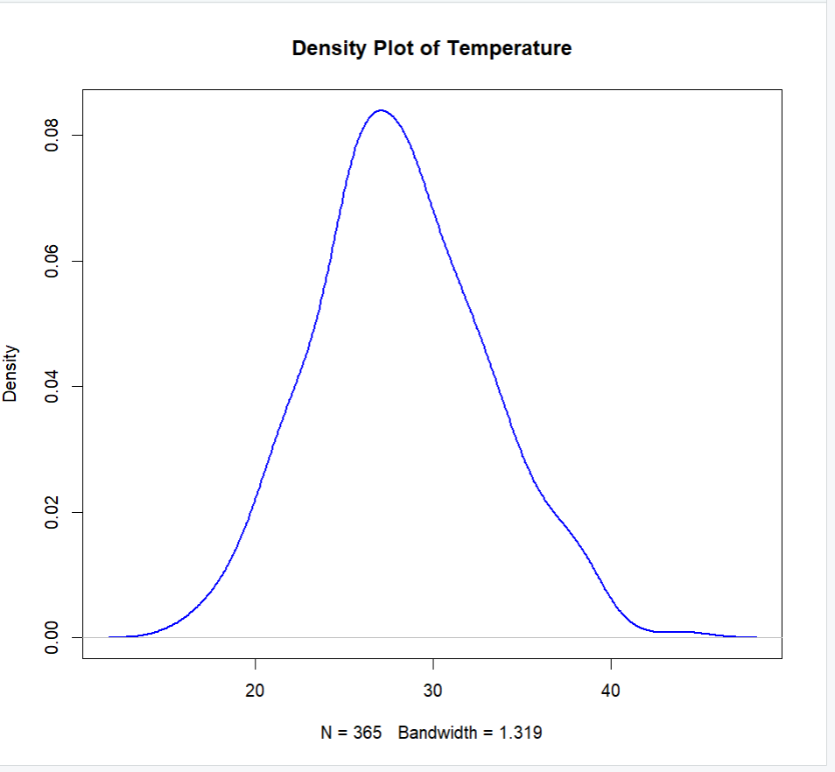
lwd = 2)

4. STUDY HOURS AND ACADEMIC ACHIEVEMENT
# =====================================================
# STUDY HOURS AND ACADEMIC ACHIEVEMENT
# =====================================================

# Generate Sample Data for 200 Students
set.seed(123)

study_hours <- round(rnorm(200, mean = 5, sd = 2), 1)
study_hours[study_hours < 0] <- abs(study_hours[study_hours < 0])

# Assume exam score increases with study hoursq
exam_scores <- 40 + 8 * study_hours + rnorm(200, mean = 0, sd = 5)

data <- data.frame(study_hours, exam_scores)

# -----------------------------------------------------
# 1. Univariate EDA
# -----------------------------------------------------

cat("Summary - Study Hours\n")
print(summary(data$study_hours))
cat("\nSummary - Exam Scores\n")
print(summary(data$exam_scores))

# Histograms
hist(data$study_hours,
main="Distribution of Study Hours",
xlab="Study Hours",
col="lightblue")

hist(data$exam_scores,
main="Distribution of Exam Scores",
xlab="Exam Scores",
col="lightgreen")

# -----------------------------------------------------
# 2. Variance and Standard Deviation
# -----------------------------------------------------

cat("\nVariance & Standard Deviation\n")
cat("Study Hours Variance:", var(data$study_hours), "\n")
cat("Study Hours SD:", sd(data$study_hours), "\n\n")

cat("Exam Scores Variance:", var(data$exam_scores), "\n")
cat("Exam Scores SD:", sd(data$exam_scores), "\n\n")

# -----------------------------------------------------
# 3. Covariance and Correlation
# -----------------------------------------------------

cov_value <- cov(data$study_hours, data$exam_scores)
cor_value <- cor(data$study_hours, data$exam_scores)

cat("Covariance:", cov_value, "\n")
cat("Correlation:", cor_value, "\n\n")

if(cor_value > 0.7){
cat("Strong Positive Relationship\n")
} else if(cor_value > 0.3){
cat("Moderate Positive Relationship\n")
} else {
cat("Weak Relationship\n")
}

# -----------------------------------------------------
# 4. Scatter Plot
# -----------------------------------------------------

plot(data$study_hours, data$exam_scores,
main="Scatter Plot: Study Hours vs Exam Scores",
xlab="Study Hours",
ylab="Exam Scores",
pch=19,
col="blue")

abline(lm(exam_scores ~ study_hours, data=data),
col="red", lwd=2)

# -----------------------------------------------------
# 5. Interpretation
# -----------------------------------------------------

cat("\nInterpretation:\n")
cat("Positive covariance and high positive correlation indicate that\n")
cat("students who study more hours tend to score higher marks.\n")
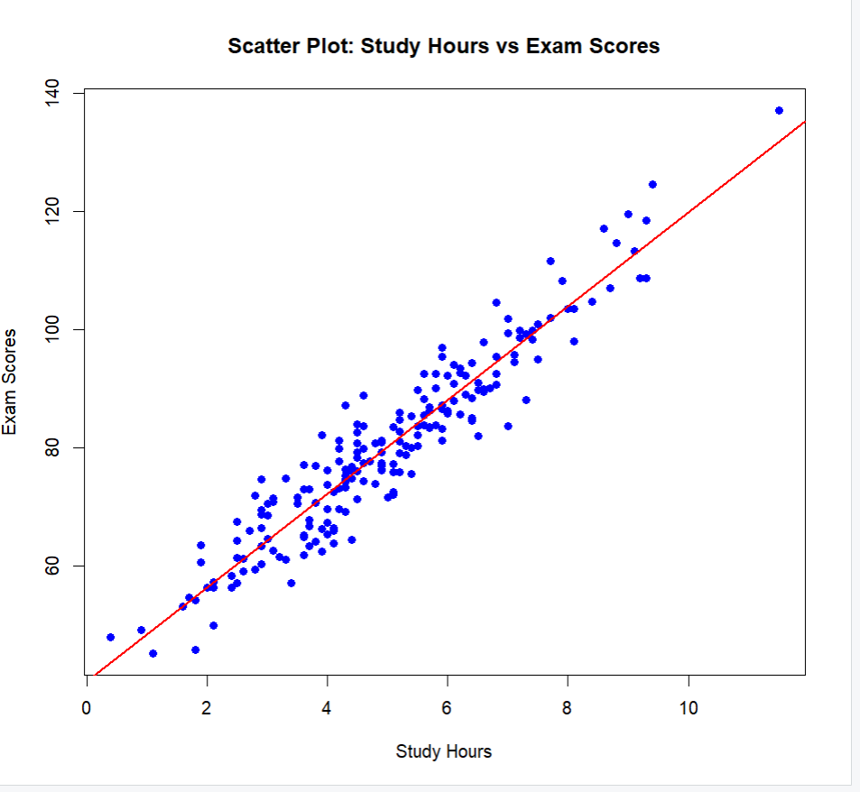
5.CUSTOMER PURCHASE PATTERN ANALYSIS
# =====================================================
# CUSTOMER PURCHASE PATTERN ANALYSIS
# =====================================================

# Generate Sample Data for 1000 Customers
set.seed(123)

items_purchased <- rpois(1000, lambda = 5) + 1

# Assume bill amount increases with number of items
total_bill <- 200 + 150 * items_purchased + rnorm(1000, mean = 0, sd = 200)

data <- data.frame(items_purchased, total_bill)

# -----------------------------------------------------
# 1. Univariate EDA for Total Bill
# -----------------------------------------------------

cat("Summary Statistics - Total Bill\n")
print(summary(data$total_bill))

# Histogram
hist(data$total_bill,
probability = TRUE,
main = "Histogram of Total Bill Amount",
xlab = "Total Bill Amount",
col = "lightblue")

lines(density(data$total_bill), col = "red", lwd = 2)

# -----------------------------------------------------
# 2. Measures of Dispersion
# -----------------------------------------------------

range_bill <- max(data$total_bill) - min(data$total_bill)
variance_bill <- var(data$total_bill)
sd_bill <- sd(data$total_bill)

cat("\nRange:", range_bill, "\n")
cat("Variance:", variance_bill, "\n")
cat("Standard Deviation:", sd_bill, "\n")

# -----------------------------------------------------
# 3. Skewness and Kurtosis (Manual Calculation)
# -----------------------------------------------------

n <- length(data$total_bill)
mean_val <- mean(data$total_bill)
sd_val <- sd(data$total_bill)

skewness <- sum((data$total_bill - mean_val)^3) / ((n - 1) * sd_val^3)
kurtosis <- sum((data$total_bill - mean_val)^4) / ((n - 1) * sd_val^4)

cat("\nSkewness:", skewness, "\n")
cat("Kurtosis:", kurtosis, "\n")

if(skewness > 0){
cat("Distribution is Positively Skewed\n")
} else if(skewness < 0){
cat("Distribution is Negatively Skewed\n")
} else {
cat("Distribution is Symmetric\n")
}

if(kurtosis > 3){
cat("Leptokurtic (Heavy Tails)\n")
} else if(kurtosis < 3){
cat("Platykurtic (Light Tails)\n")
} else {
cat("Mesokurtic (Normal Distribution)\n")
}

# -----------------------------------------------------
# 4. Covariance and Correlation
# -----------------------------------------------------

cov_value <- cov(data$items_purchased, data$total_bill)
cor_value <- cor(data$items_purchased, data$total_bill)

cat("\nCovariance:", cov_value, "\n")
cat("Correlation:", cor_value, "\n")

if(cor_value > 0.7){
cat("Strong Positive Relationship\n")
} else if(cor_value > 0.3){
cat("Moderate Positive Relationship\n")
} else {
cat("Weak Relationship\n")
}

# -----------------------------------------------------
# 5. Scatter Plot
# -----------------------------------------------------

plot(data$items_purchased, data$total_bill,
main = "Scatter Plot: Items Purchased vs Total Bill",
xlab = "Number of Items Purchased",
ylab = "Total Bill Amount",
pch = 19,
col = "blue")

abline(lm(total_bill ~ items_purchased, data=data),
col = "red", lwd = 2)

# -----------------------------------------------------
# 6. Explanation
# -----------------------------------------------------

cat("\nDifference Between Univariate and Bivariate EDA:\n")
cat("Univariate EDA analyzes one variable at a time (e.g., total bill).\n")
cat("Bivariate EDA analyzes relationship between two variables (items and bill).\n")
cat("Here, univariate shows distribution and variability of bill amount,\n")
cat("while bivariate shows how number of items influences total spending.\n")
